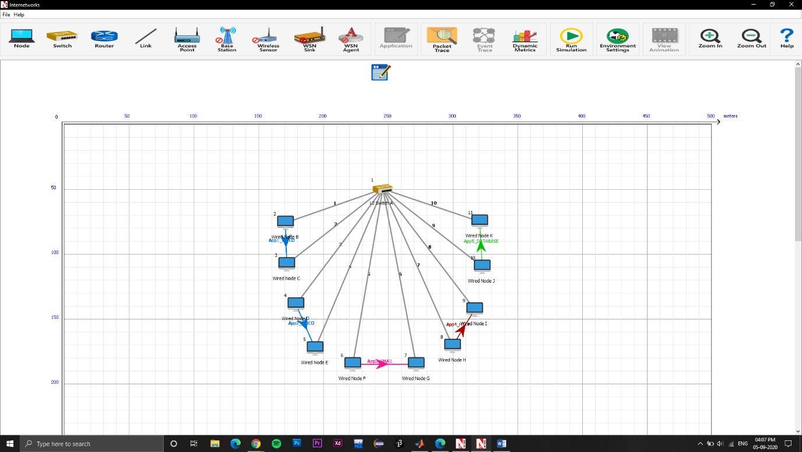**3.1** diagrams

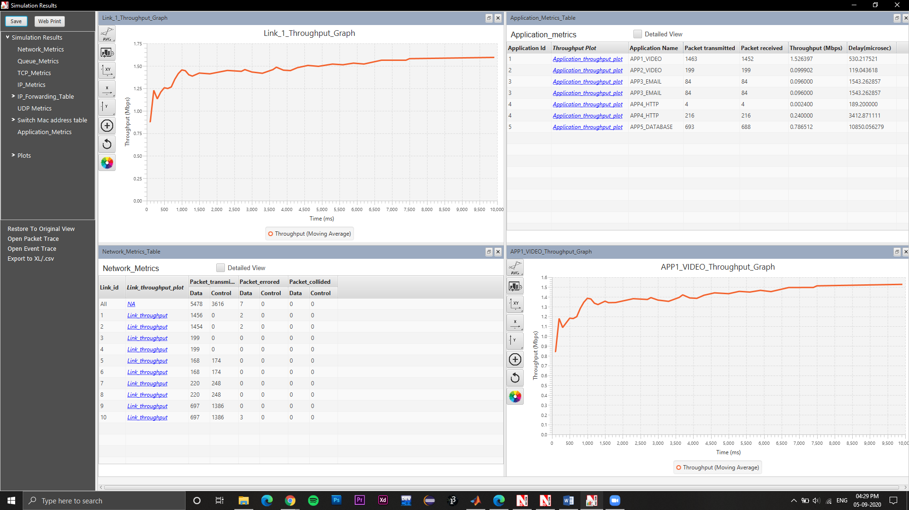

1. HD Video = 1.526397 Mbps

YouTube = 0.099902 Mbps

Gmail = 0.096000 Mbps

Browsing (1) = 0.002400 Mbps

Browsing (2) = 0.240000 Mbps

Database = 0.786512 Mbps

1. 0.8131495 Mbps
2. 0.406774 Mbps
   1. Diagrams

**4.3.1**

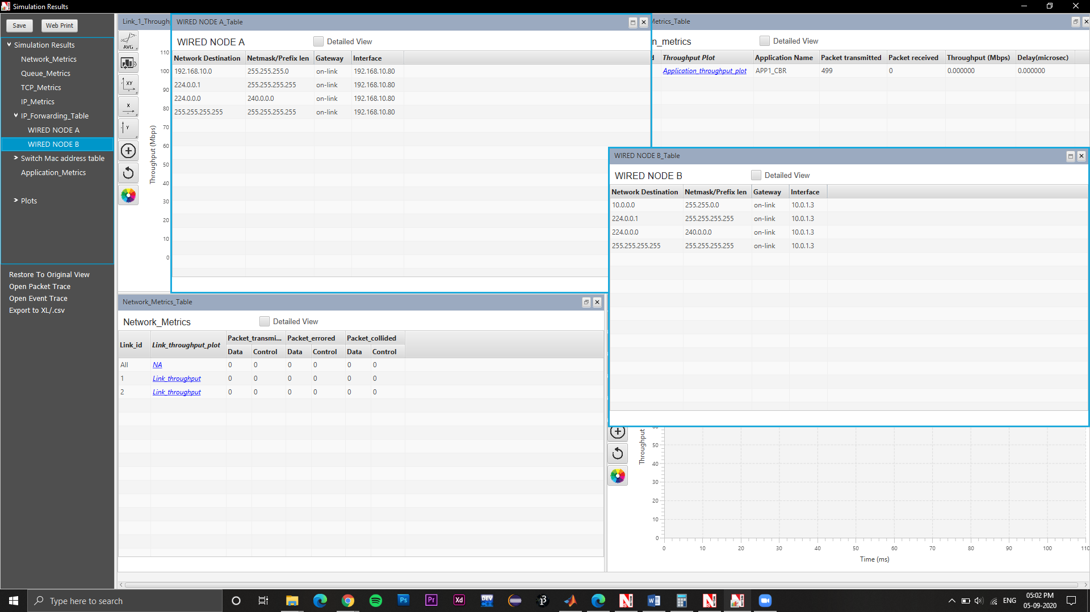

1. Refer the diagram for the list of IPs

2. 499

3. 0 since the IP range/class is different for both

**4.4.1**

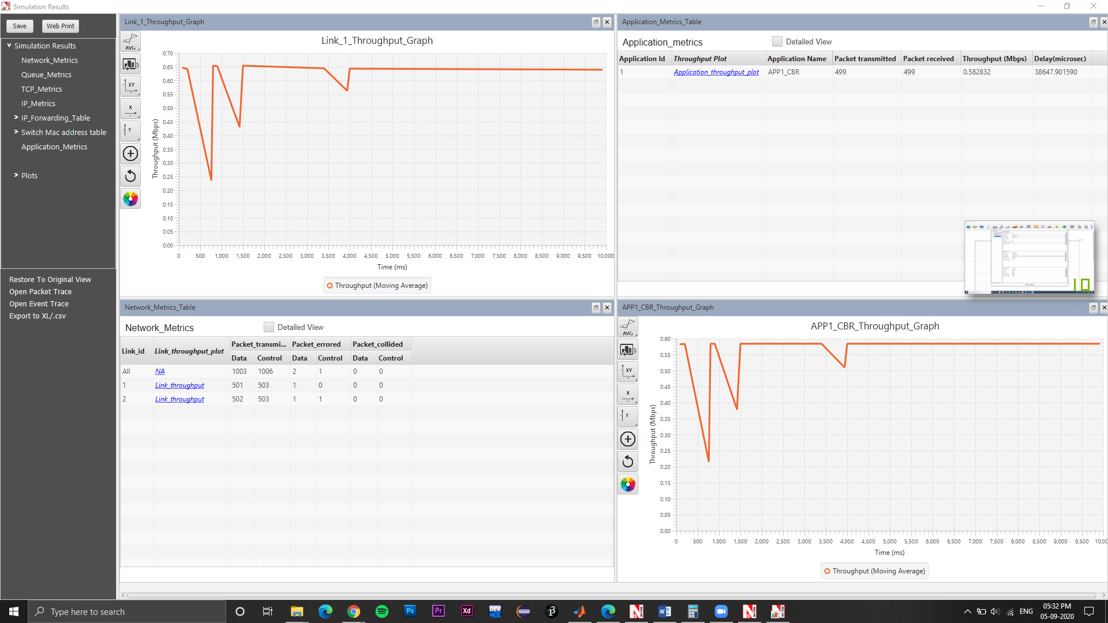

1. Refer the screenshot
2. 499 because this time the IP range/class is same for both nodes.

**5.1**

**5.1.1**

1. Ethernet adapter Ethernet: 0C-9D-92-A4-00-BE

Wireless LAN adapter Local Area Connection* 3: 34-E1-2D-15-59-1F

Wireless LAN adapter Local Area Connection* 12: 36-E1-2D-15-59-1E

Wireless LAN adapter Wi-Fi: 34-E1-2D-15-59-1E

1. I have 4 physical addresses because of 4 NICs working currently
2. IPv4 Address : 192.168.1.9(Preferred)

Subnet Mask : 255.255.255.0

**5.2**

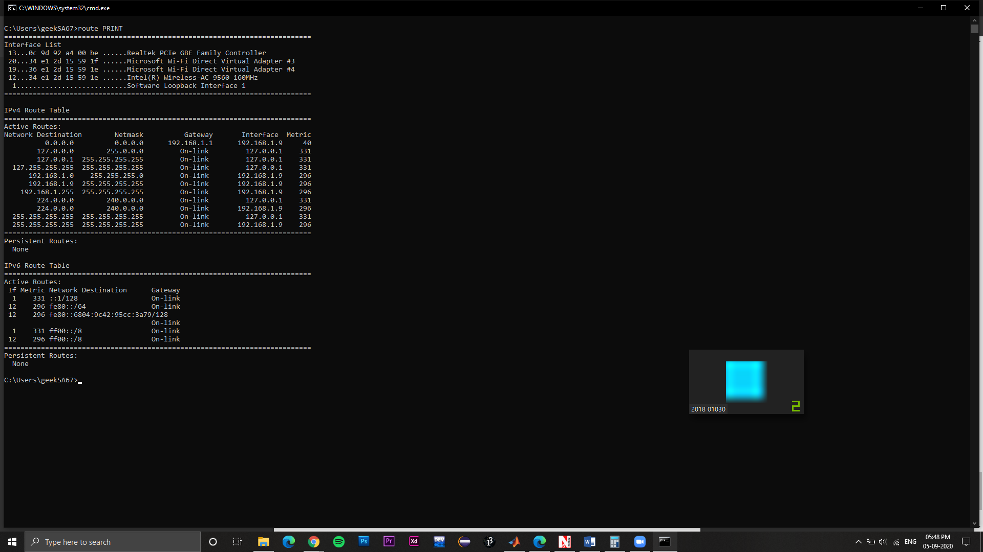1. refer the screenshot

2.

Ping statistics for 104.238.110.159:

Packets: Sent = 4, Received = 4, Lost = 0 (0% loss),

Approximate round trip times in milli-seconds:

Minimum = 289ms, Maximum = 292ms, Average = 290ms

3.

Ping statistics for 192.168.1.10:

Packets: Sent = 4, Received = 4, Lost = 0 (0% loss),

Approximate round trip times in milli-seconds:

Minimum = 44ms, Maximum = 96ms, Average = 69ms

1. I pinged my friend’s IP connected on the same network and clearly the time taken is less since the physical and network distance are significantly.

5. Tracing route to google.com [216.58.196.206]

**over a maximum of 30 hops:**

1 1 ms 1 ms 1 ms 192.168.1.1

2 6 ms 5 ms 6 ms abts-north-static-070.127.176.122.airtelbroadband.in [122.176.127.70]

3 6 ms 6 ms 5 ms dsl-ncr-static-001.81.16.125.airtelbroadband.in [125.16.81.1]

4 6 ms 6 ms 6 ms 182.79.149.182

5 8 ms 8 ms 7 ms 72.14.217.194

6 7 ms 7 ms 7 ms 172.253.69.191

7 7 ms 7 ms 7 ms 216.239.47.99

8 7 ms 7 ms 7 ms del03s06-in-f14.1e100.net [216.58.196.206]

Trace complete.

6. There is a difference because all websites are different their servers and network routes are different and have different amount of traffic so the results will vary accordingly.

Refer the screenshots for outputs.

